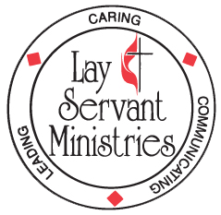
DISTRICT LEADERSHIP and LAY SERVANT ACADEMY
UPCOMING - 5-week class (Mondays, 6:30 PM – 8:30 PM):

God’s Mission…Our Journey (Advanced Course)

Taught by Rev. Cindy Boggs VIA ZOOM and in person at First UMC, Shinnston

God’s Mission…Our Journey (Advanced Course) Dates: Feb. 22, March 1, 8, 15, 22

This course will provide participants with a better understanding of a holistic approach to participation in God’s mission to the world and equip lay servants for more effective missional engagement in their communities and beyond.

This is a small group study. Attendance at all five classes is required to receive credit if you are on the lay servant pathway. There is no charge for this class - you will need to purchase the text “A Mission Journey: A Handbook for Volunteers” participant’s book on your own – it is available from Amazon (ISBN #: 9780835817868) in kindle and paperback versions. (Please allow plenty of time for delivery).

Registration deadline is February 15th.

Questions regarding the course may be directed to Mary Bane at 304-692-0003 or by email to crazymcb1@gmail.com.

Send the completed form to: MonValley District UMC
Deadline is Feb. 15th PO Box 307
Kingmont, WV 26578

God’s Mission…Our Journey Advanced Course 5 weeks: Feb. 22 – March 22, 2021
(Rev. Cindy Boggs) 6:30 – 8:30 PM
PLEASE PRINT

Name:

Mailing address:

City: ____ State: Zip:

Home telephone: E-mail:

Local church: Pastor:

I have obtained my copy of “A Mission Journey: A Handbook for Volunteers”

 I plan to attend via Zoom  I plan to attend in person at First UMC Shinnston

Type of Study (Check one only)
( ) Self-Improvement ( ) Certified Lay Servant ( ) Certified Lay Speaker

